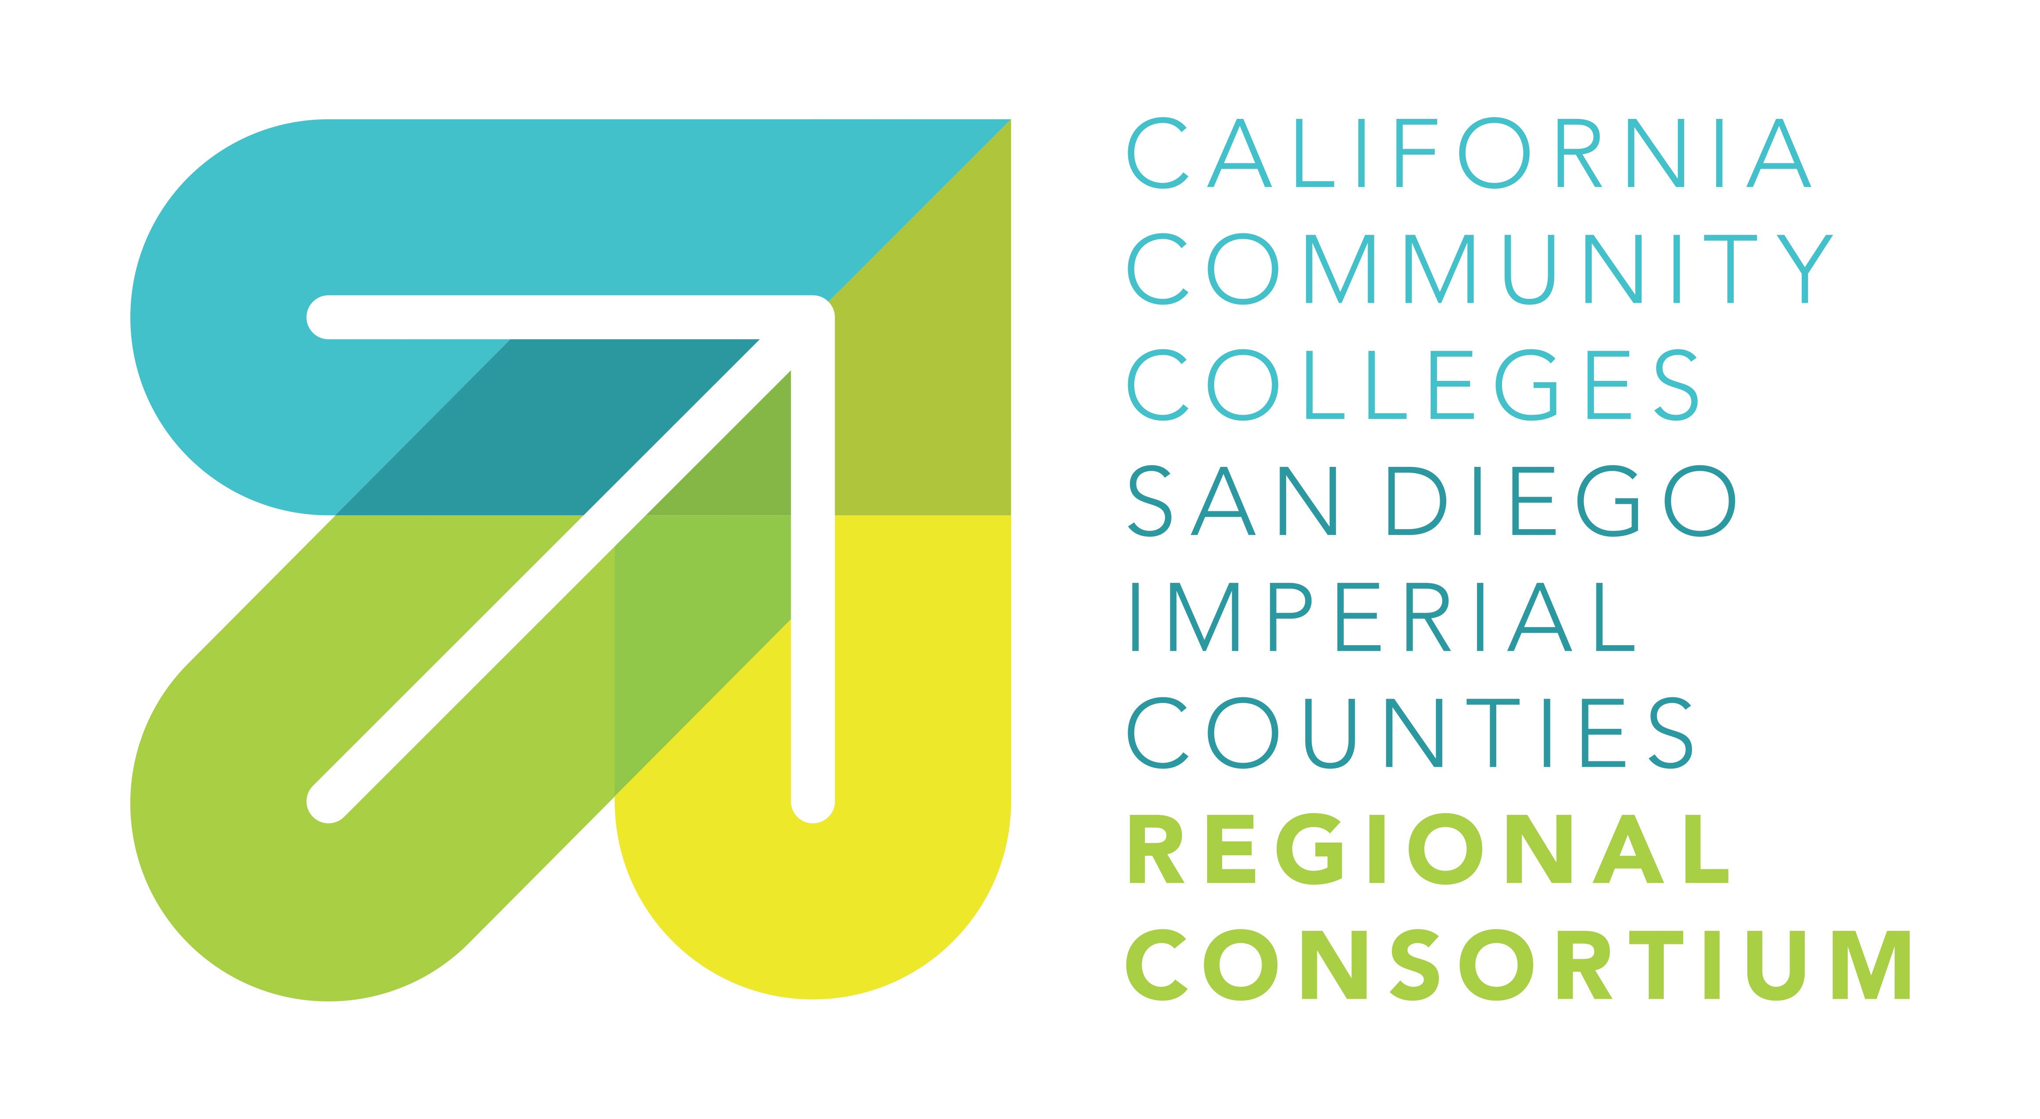

Southern Border Regional Workforce Development Plan
Regional Meeting of Partners

November 7, 2016

Draft Outcomes

Based on an understanding of the labor market demand/supply workforce needs and gap analysis of the region, reached consensus on:

- Sectors that are the drivers of the regional economy: Identified 18 sectors; agreed to focus regional efforts on top four:

      - Health
      - Clean Energy/Advanced Transportation
      - Advanced Manufacturing
      - ICT.

- Agreement on ten core strategic workforce development
priorities, with a focus as a region on:

      - Coordinate industry engagement & single entry point for business customers
      - Create opportunity for all San Diego & Imperial County residents through Career Pathways
      - Support human-centered approach to service design.

Supporting documents including Labor Market Research presentations are posted on the Regional Consortium website: myworkforceconnection.org

