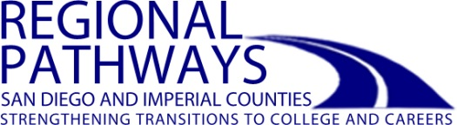

2017-18 Supported Events

- HASPI Educator Conference – October 17, Marina Village
- Behind the Scenes in ICT Educator Workshop – November 14, City College
- Men in Nursing Student Event – December 1, Grossmont College
- Counselor Conference-Career First – December 5, Marina Village
- Biotech Day – February 13, Miramar College
- Codechella Student Event – February (TBD), Grossmont College
- Sector-wide Careers in Public Service Student Event – March 1, Marina Village
- Nursing Revealed Student Event – March (TBD), SDSU
- Student Health Career Expo – April 6, Southwestern College
- Global Manufacturing Educator Workshop – April 26, Southwestern College
- Automotive Skills Day for Students – May (TBD), Cuyamaca College
- Sustainability Student Expo – Spring (TBD)

http://www.careeracademics.org/

