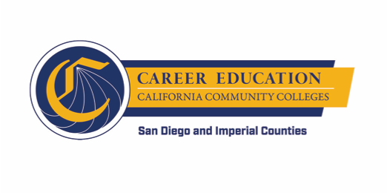
SWP - Implementation
WORKGROUP #3: PATHWAY NAVIGATION
AGENDA
Thursday, October 4, 2018
10:00 a.m. - 12:00 p.m.
Miramar College – Room L-108

- INTRODUCTION AND OVERVIEW (approx. 10 minutes)
  - Overview of Agenda
  - Updates (if any)

- DIGGING INTO THE WORK – Support and Review of Applications (approx. 60 minutes)
  - Pre-RFA Informational Session
  - Quality Criteria
  - Self-Assessments and One-on-One Consultations
  - Final Application Review
  - Next Steps

- DIGGING INTO THE WORK – Student Success Technology (approx. 45 minutes)
  - Technology Opportunity Assessment Workshop
  - Next Steps

- WRAP UP (approx. 5 minutes)

