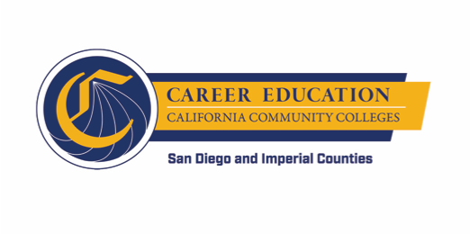
SWP - Implementation
WORKGROUP #3: PATHWAY NAVIGATION
AGENDA
Wednesday, September 5, 2018
10:00 a.m. - 12:00 p.m.
Miramar College – Room L-108

- INTRODUCTION AND STATUS (approx. 10 minutes)
  - Agenda Overview
  - Updates since last meeting

- DIGGING INTO THE WORK – Pre-RFA Informational Session (approx. 15 minutes)
  - Revised Draft agenda
  - Announcement, Outreach, and Logistics
  - Connection to Technology Opportunity Assessment Workshop

- DIGGING INTO THE WORK – Near Final Draft RFA and Self-Assessment (approx. 80 minutes)
  - General Review
  - Leading Indicators
  - Quality Criteria
  - Self-Assessment

- DIGGING INTO THE WORK – Career Exploration/Planning Tools (approx. 10 minutes)
  - Preliminary Discussion on Available Tools, e.g., MyPath
  - Next Steps

- WRAP UP AND NEXT STEPS (approx. 5 minutes)

