Workforce & Economic Development
October 2018

Perkins Master Calendar  Doing What Matters  CTE Transitions  Title I-B | Title I-C  WED  Competitive RFAs

Perkins/CTE Federal Issues
Perkins V
H.R. 2353, the Strengthening Career and Technical Education for the 21st Century Act, known in short as “Perkins V,” has now reauthorized as of July 31, 2018. A transition plan for this funding will be due to the Federal Government by April 2019 and a 4-year statewide plan will be due by April 2020. If the interim plan requirements are the same as in past reauthorizations it will minimally require additional narrative within the Title I-C interim District application detailing how the District will use the interim year to become ready to implement Perkins V.

Perkins IV Title I-C Allocations 2018-19
As specified in the June update and the original allocation memo sent to the Districts, we expect to get final allocations for Title I-C basic grant funding by October 2018 and will give instructions for amending amounts as soon as the final allocations are determined. We do expect that if the allocations change they will go down not up.

2018-19 Perkins Master Calendar Dates
October 1, 2018 -- District 2017-18 Financial Aid data due to the Chancellor’s Office.
December 1, 2018 -- This is the deadline for resubmission of 2017-18 Financial Aid data for use in the SFA reconciliation for 2017-18 BFAP-SFAA administrative funding.

Quarterly Reporting – Every quarter districts are required to report and certify their Perkins Title I-C, CTE Transitions, and Title I-B expenditures in the Year-To-Date Expenditures and Progress Report online system. The reporting schedule ensures that districts are reimbursed in a timely manner. The following reporting dates will apply for FY 2018-19.

Quarters District Certified Deadline
- First Quarter October 15, 2018
- Second Quarter January 15, 2019
- Third Quarter April 15, 2019
- Fourth Quarter July 15, 2019
- Final Claims August 31, 2019

Doing What Matters

September 2018 Issue
In This Issue
Ton-Quinlivan Selected for Executive-in-Residence at Silicon Valley's Institute for the Future
Ryan Craig Releases New Book about Forces Seeding Cheaper and Faster Alternatives to College
Lynn Shaw Featured in Apprenticeship Documentary
Apply for $1 Billion Wage Gain Challenge
Workforce Division Staff Tours Impacts of Strong Workforce Funds at Sierra College
Now Available: Career Education Campaign Collateral Materials
LaunchBoard Update: Disaggregated Data

Other

AEBG
Technical Assistance Provider Calendar

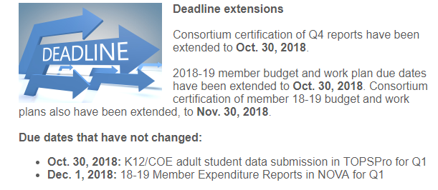
AEBG Webinar Schedule
Andragogy for 21st Century
Wednesday, Oct. 10 | 12 p.m.-1 p.m.
Learn more and register

Leveraging AEBG to Improve Community Partnerships
Wednesday, Oct. 24 | 12 p.m.-1 p.m.
Learn more and register

Beginning of the Year Adult Education
Wednesday, Oct. 24 | 1:30 p.m.-3 p.m.
Learn more and register

Implementing a Data Dialogue Protocol to Target Instruction and Improve Student Outcomes
Monday, Oct. 29 | 2:30 p.m.-4 p.m.
Learn more and register

Using Assessment Results to Inform Instruction
Tuesday, Oct. 30 | 2:30 p.m.-4 p.m.
Learn more and register

Submit a Support Request

The Technical Assistance Project (TAP) is a support service for California Adult Education program consortia members and associates who need assistance related to grant funding.

Members and associates can submit a support request to receive help on grant funding, governance, planning, policy, reporting and professional development.

2018 Press Releases –

OCTOBER

October 2, 2018

Press Release — Fifty-nine California Community Colleges to Receive $8.5 Million in Grant Funding to Expand College Veterans Resource Centers (doc) (pdf) (txt) (html)

SEPTEMBER

September 27, 2018

Press Release — Fifty-nine California Community Colleges to Receive $8.5 Million in Grant Funding to Expand College Veterans Resource Centers (doc) (pdf) (txt) (html)

CIO CSSO Newsletter –Look for these under notes and new on the left side of the page at this link. The October 2018 newsletter has been posted and contains updates on the following:
Guided Pathway Regional Strategy Update
Caring Camus Project
Vision Resource Center Lunches
AB 705 Professional Development
Curriculum Inventory System End User Training Sessions
Curriculum Inventory System Fall Release
Campus Safety and Sexual Assault
Student Equity and Achievement Program Fall Trainings
Zero Textbook Cost Program
CCCApply Redesign

State Relations -- The Chancellor's Office State Relations Site is a great resource.

Federal Relations -- The Chancellor's Office Federal Relations Site is a great resource.

