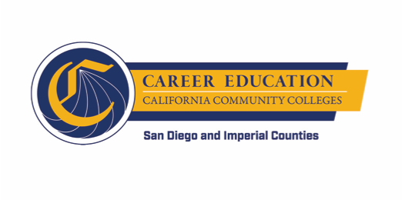
SWP - Implementation
Implementation Committee Check-in

Wednesday, October 17, 2018
12:30-2:30 PM PST

- Agenda Overview

- Action Items
  - Work Group Action Plan (60 min)
    - Recommendations for goal setting
    - Recommendations for data collection
    - Relationships among WBL Coordinators, Job Placement Coordinators, existing campus resources, and regional structure
    - Lessons from CCCAOE & Dr. Farouk Dey

- Discussion Items
  - WBL mapping exercises con’t (30 min) – WestEd
  - WBL Assessment (30 min)
    - Timeline
    - Glossaries
    - Training Feedback

