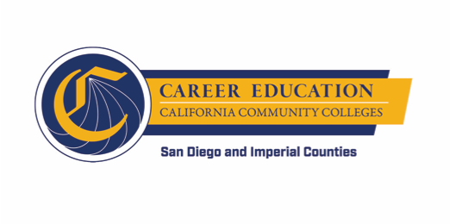
K-14 Career Pathways Subcommittee Meeting
September 10, 2018
12:30 PM – 2:30 PM

San Diego Continuing Education
North City Campus – 115G

AGENDA

- Career pathways goals and leading indicators J. Patel & K. Porter
  - Review document
  - Align metrics/goals/leading indicators

- Career Development Continuum L. McConville
  - Review Continuum and Rubric

- Next steps M. Smith/J. Patel
- Large group meeting
- Small group meeting

