Work-based Learning Definition

Work-Based Learning: A continuum of experiences that support career awareness, career exploration, and career preparation, through engagement with employers and real work opportunities. Work-based learning experiences are connected to curriculum and range in intensity, from tours and job shadowing, which expose students to career options, to internships, work experience, co-op, and apprenticeships, which teach both general and specific career-related skills through actual work. High intensity WBL can also include projects completed, or services performed, in classrooms, if employers are directly involved, or if the projects and services are being developed/performed for a client outside of class. Examples include a web development project or service for a local non-profit organization. Any high intensity WBL experience requires a learning plan, assessment, and adherence to other criteria for high quality and safe practice. Work-based learning, while sometimes coordinated by staff outside the pathway, is integral to both Pathway Participation and Career and Employment Preparation and connects the two. (from ERJP Glossary)

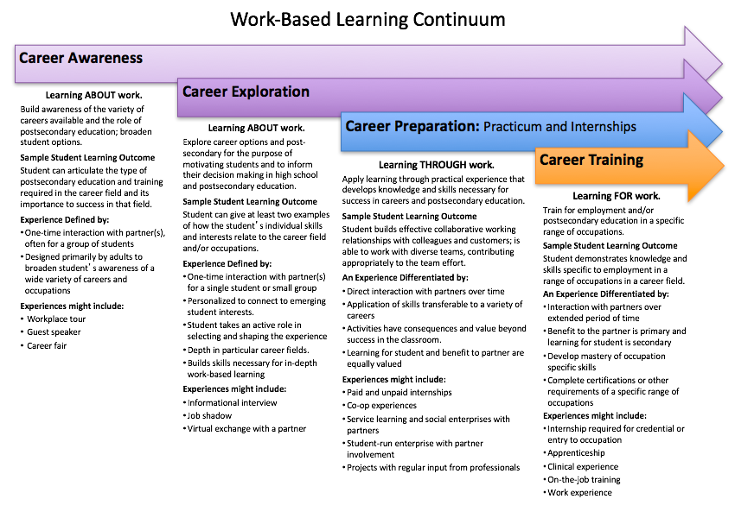

Source: Linked Learning Alliance (2012).

