DRAFT DRAFT Information to be Collected from Faculty DRAFT DRAFT
DRAFT Interested in Presenting a Skills Lesson/Best Practice at the Regional Skills Symposium DRAFT
DRAFT (To Determine an Appropriate Mix of Colleges, Disciplines, and 21ST Century Skills) DRAFT

Faculty Member’s Name:

College: Phone:

Faculty Member’s Email:

Which Skill Lesson or Best Practice do you propose to share from the list below. Check a maximum of 2. If selected to present, you will receive a $350 stipend per skill presented at the Regional Symposium:

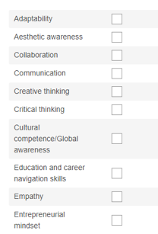
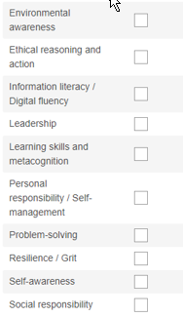

One of the desired outcomes of the Regional Symposium is that attendees become motivated to create a similar lesson for implementation in fall 2019. With this outcome in mind, please describe your presentation.

Please circle all the days below you could be available to present your skills lesson/best practice to help the region’s Strong Workforce: 21st Century Skills Workgroup select an optimal date for the Symposium.
NOTE: Funds for substitutes are available.
Tuesday Wednesday Thursday Friday
April 2 April 3 April 4 April 5
April 9 April 10 April 11 April 12
April 23 April 24 April 25 April 26

SAVE THE DATE: New World of Work Training will be provided on Thursday, 4/18/19, and Friday, 4/19/19.* *Must attend both days to receive certificate and to access all 20 lesson plans, materials, and PPTs.
THANK YOU!

