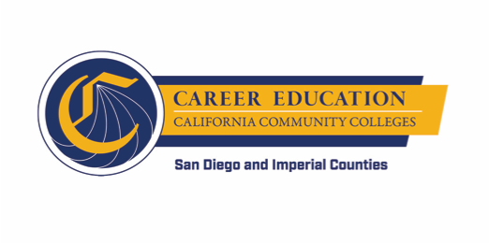
SWP - Implementation
WORKGROUP #3: PATHWAY NAVIGATION
AGENDA
Thursday, November 8, 2018
10:00 a.m. - 12:00 p.m.
Miramar College – Room L-108

- INTRODUCTION AND OVERVIEW (approx. 10 minutes)
  - Overview of Agenda
  - General Updates (if any)

- PATHWAY NAVIGATION – RFA Consultations (approx. 15 minutes)
  - Status
  - Definitions
  - FAQs

- PATHWAY NAVIGATION – Technology Workshop Results (approx. 10 minutes)

- PATHWAY NAVIGATION PLAN IMPLEMENTATION LAUNCH – Convening of Colleges (approx. 20 minutes)
  - Date
  - Outcomes
  - Topics

- CHANGE MANAGEMENT – Tips and Tricks (approx. 35 minutes)
  - Workgroup member experiences with application development process

- PROBLEM OF PRACTICE (approx. 25 minutes)
  - Role of Institutional Research Offices (e.g., looking at intake data)

- WRAP UP (approx. 5 minutes)
  - December meeting date (possible change)

