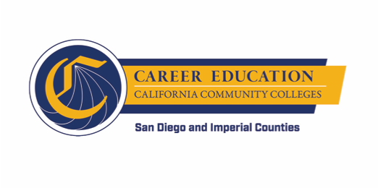
SWP - Implementation
WORKGROUP #3: PATHWAY NAVIGATION
AGENDA
Thursday, December 6, 2018
10:00 a.m. - 12:00 p.m.
Miramar College – Room L-108

- INTRODUCTION AND OVERVIEW (approx. 10 minutes)
  - Overview of Agenda

- PATHWAY NAVIGATION – General Updates (approx. 20 minutes)
  - RFA Submissions
  - Technology Research and Analysis
  - Other

- CHANGE MANAGEMENT – Tips and Tricks (approx. 30 minutes)
  - Workgroup member experiences with application development process

- PATHWAY NAVIGATION PLAN IMPLEMENTATION LAUNCH – Convening of Colleges (approx. 55 minutes)
  - Date
  - Outcomes
  - Topics

- WRAP UP (approx. 5 minutes)
  - Spring meeting calendar

