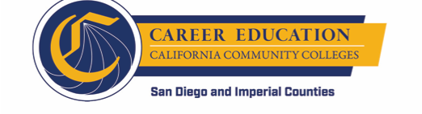
SWP - Implementation Committee
Monthly Check-in
AGENDA

Friday, January 11, 2019
9:00 – 11:00 a.m.

Mesa College:
Learning Resource Center, 4th floor (LRC-435)

- AGENDA OVERVIEW

- WORKGROUP STATUS UPDATES
  - Workgroup status updates (anything new since meeting on December 14)

- CROSS-CUTTING TOPICS/UPDATES
  - February 4 CEO Workshop – 8:30 to 11:30 at SDCE Ocean View Campus
            - Presentation
            - Goals, Leading Indicators, Accomplishments, Next Steps
            - Logic Model
  - Shared calendar (new Google doc)
  - Technology Task Force
  - Knowledge Management
            - Best Practices
            - Communities of Practice (CoP)
            - Informational Web Site
            - “Journey”
            - Article

- WRAP UP

