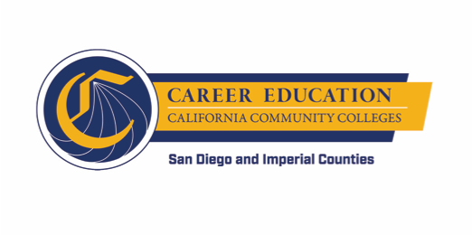
SWP - Implementation Committee
Monthly Check-in
AGENDA

Friday, November 9, 2018
12:30 p.m. – 2:30 p.m.

Mesa College:
Learning Resource Center, 4th floor (LRC-435)

- AGENDA OVERVIEW

- Debrief CEO Presentation
  - CEO requests

- WORKGROUP SHARING
  - Items not shared in the earlier meetings (and need to be shared)

- CROSS WORKGROUP TOPICAL DISCUSSION
  - Information Collection and Dissemination
    - Article
    - Journey “Documentary”
    - Repository of Resources
  - Data collection
  - Technology
    - Follow up to Jobspeaker questions
    - CRM research

- WRAP UP

