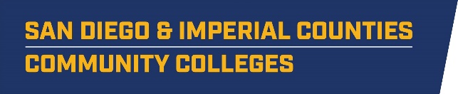

SWP - Implementation
WORKGROUP #2: MS/HS Engagement
AGENDA
Thursday, April 11, 2019
2:00 p.m. - 4:00 p.m.
Miramar College – Room L-108

- INTRODUCTIONS AND OVERVIEW J. Lopez/J. Lewis
  - Overview of Agenda

- MEETING OUTCOMES M. Smith

- STRATEGIC PLANNING J. Lopez/J. Lewis
  - Purpose of the workgroup
  - Current Purpose Statement: The purpose of this workgroup is to better prepare K-12 students for community college and career opportunities through robust career exploration, engagement, and exposure. This workgroup will also ensure that parents and educators are part of the student preparation process and are made aware of the countless high-wage, high-demand jobs available for students.
  - Blue wall activity
    - Framing:
      - Consider the 4 domains in the MS and HS CD continuum documents identified as areas of practice for MSs and HSs
      - How do we leverage this work to support K-12 in preparing students for entry into community college and careers? for example:
        - Regional activities (like industry-focused career fairs) that provide economies of scale and add value to what the LEAs are doing
        - Research, models, templates, tools, dissemination, and possibly a community of practice to support best practices, learning and collaboration
    - Big question for the blue wall:
What does it look like when the Consortium effectively supports K-12 in preparing students for entry into community college and careers?

- WRAP UP

