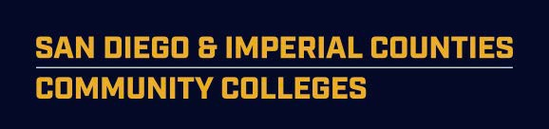

SDIC Community College Dean’s Council Meeting

May 10, 9 – 10:30 Mesa College AGENDA

1 669 900 6833 (US Toll)
Meeting ID: 956 274 285

Time Item Speaker

9:00 1. Welcome/Introductions D. Brown

9:00 2. Minutes from 3.8.19 (handout) D. Brown

9:05 (20 min) 3. Program Recommendations D. Brown
- LMI Protocol/Timing (handout) D. Brown
- Annual Credit Course & Program Certification Clarification A. Taccone

City College
- Interaction Design - A.S. Degree
- Interaction Design - Certificate of Achievement
- Green Building Energy Professional - A.S. Degree
- Green Building Energy Professional - Certificate of Achievement

MiraCosta College
- Medical Office Clinical and Administrative Professional

Imperial Valley College
- Microsoft Office - Certificate of Achievement

9:25 (50 min) 4. Strong Workforce Implementation M. Smith

- Student Success and Support: SWP Institute (handout) M. Smith/T.Ngo Bartel
Early Fall, Flyer, RFA
- WBL/JP Hiring (handout) B. Gamboa
- Program Mapper – wave 2 B. Gamboa
- PD Coordinator RFA (handout) M. Smith
- WestEd Article (handout)

10:15 (10 min) 5. Fiscal Agent Report S. Cox
  - Regional Plan (handout)
  - 17-19 Extensions

10:25 (5 min) 6. Other
- WBL Summit (handout) L. Wisdom
- Counselor Conference L. Wisdom

Next meeting June 14, 2019 Mesa College - 7250 Mesa College Dr, San Diego, CA 92111 – NEW Business and Technology Building, room TBD.

