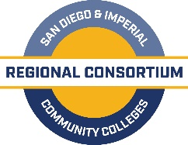

K-14 Pathways Partnership Meeting

A G E N D A

May 22, 2019
San Diego Continuing Ed- North City Campus
1 PM - 3 PM

- Welcome and Introductions – (5 mins) J. Patel

- Meeting Overview (2 mins) K. Porter

- INTRODUCTIONS AND OVERVIEW (10 minutes) R. Tillery
  - Project Overview

- K12-CC MAPPING TOOL – Overview/Show and Tell (10 minutes) K. Beltramo
  - Construction and Structure
  - Demonstration
  - Vocabulary – Definitions Page

- HANDS-ON TOOL EXPLORATION (15 minutes) All
  - Prompt Sheet

- GROUP DISCUSSION (15 minutes) R. Tillery and K. Beltramo
  - What kind of searches did you do?
  - How easy was it to find information using the tool?
  - In what circumstances might you use a tool like this?
  - Who would benefit from having access to this type of tool (e.g., faculty, counselors, others)?

- SDIC Tableau Pathways Tool (25 minutes) R. Tillery
  - Overview
  - Demonstration
  - General Impressions/Discussion

- Recap and Next Steps (10 minutes) R. Tillery and K. Beltramo

- Status of K-12 SWP (12 mins) M. Smith
  - Information
  - Survey- Career Pathways Assessment- Due May 24th L. Wisdom

- Closing (1 mins) J. Patel

