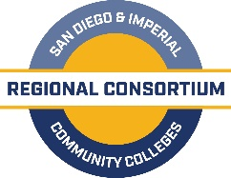

K-14 Pathways Partnership Meeting

A G E N D A

September 18, 2019
San Diego Continuing Education North City Campus, 8355 Aero Drive, Multipurpose Rm
10-11:30 am

- Welcome and Introductions (5 mins) J. Patel

- Meeting Overview (2 mins) B. Lane

- Career Pathways Goals (20 mins)(handout) K. Porter

- K12-CC Mapping Tool (15 mins)(handout) S. Hale

- Status of K-12 SWP (6 mins)(handout) K. Zant
  - Timeline
  - Regional Trainings

- 2019-2020 MS/HS Engmt Goals/Act plan (10 mins)(handout) H. Cavazos/M. Rosas

- Updates on Adult Education (2 mins) K. Zant

- Collaborative Break-outs (25 mins) K. Porter
  - Best Practices
  - Future Meeting Topics

- Closing (5 mins) J. Patel

For Zoom meeting connection:
https://cccconfer.zoom.us/j/634054130
+1-669-900-6833 OR +1-646-876-9923
Meeting ID: 634 054 130

