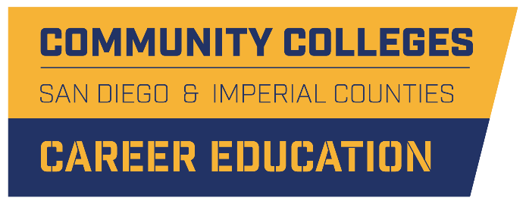

K12/CC Pathway Mapping Tool: Recommendations

REPORT SUMMARY
August 28, 2019

Recommendations Summary

The initial project requirement was to develop an interactive tool that maps Career Education programs from K-12 to the community colleges. In discussing this type of tool, several other requested features were introduced by stakeholders, such as connecting to labor market data, career exploration, and managing student-level activities. Because of the expanded scope of the requested mapping tool and the fact that no single tool currently addresses all the requirements, the overall recommendation is to engage in an iterative process to meet the full complement of requirements while addressing priority needs by implementing two existing tools. Specifically, start by engaging with Orange County and Concentric Sky to implement the Program Finder tool to showcase San Diego/Imperial County K12 and CC pathways data. Then, determine next stage(s) of the project based on priorities and develop a project plan that may include:
- Enhancements to the Program Finder (e.g., displaying dual enrollment information)
- Adopting the Bakersfield College Program Pathways Mapper tool to showcase the 10 colleges’ pathway maps and career information
- Enhancing the Pathways Mapper (e.g., to include K12 coursework)
- Connecting to more robust career exploration tools

Recommendation Detail

Recommendation 1: Prioritize Requirements of Comprehensive K12/CC Pathway Mapping Tool
A key next step is to prioritize the various requested features to inform final design and requirements of a K12/CC pathway mapping tool. This work will also inform development of a detailed implementation plan. Table 1 below lists the user requirements organized by type of user and identifies which of those requirements are addressed by tools described in the full report.
Table 1: User Requirements Addressed by Various Tool Options
 | Orange | Bakersfield | Career Exploration | Excel Pivot Tables*
Students (and parents) need tools to:
- Explore CE programs available at their high school (or neighboring high schools) | X
- Explore CE programs available at local community colleges | X | X | X
- Explore opportunities for articulation/dual enrollment
- Research careers (especially those aligned to high-demand jobs in the region) |  | X | X
- Explore the education requirements for careers of interest |  | X | X
- View pathways that lead to education goals, including specific coursework requirements and where those courses are offered |  | X
- Make connections to community colleges (e.g., career center or admissions office) | X |  | X
Counselors and educators additionally need tools to:
- See what students are interested in (e.g., high school pathways, careers, colleges, types of programs) |  |  | X
- Track where students are taking college courses | X
K12 District Leaders/Administrators additionally need tools to:
- Identify opportunities for aligning with labor market trends
- Identify opportunities for aligning with college programs | X |  |  | X
- Track outcomes of students who continued a pathway in college
College Program Directors need tools to:
- Identify opportunities for aligning with labor market trends
- Identify opportunities for aligning with high schools | X |  |  | X
- Identify students in HS pathways for outreach activities
- Track outcomes of students
*These pivot tables are not intended to be final products, but offer an interim solution while a final, comprehensive tool is designed

Recommendation 2: Establish Data Collection and Management Processes
Leveraging the work completed in phase one (i.e., data collected to inform pathways), the data for the tool should be updated at least once a year. The California Department of Education publishes de-identified data sets of student enrollment, including administrative and demographic information. It is possible to pull in more detailed school information (e.g., address) and course titles, pathways, and sectors for CE courses by joining the data sets provided on the CDE website. This would likely be the primary method to get regularly updated course and enrollment information (and this is how Orange County populates their tool), although it’s unclear how often data is updated on the CDE website. If the Region was able to get an MOU and data agreement with CALPADS to have access to more current data vs. an annual downloading of files off the website, that would be preferable (although perhaps not a realistic option).

There would also need to be a high level of confidence that the data are accurate and it is recommended that a verification process occur each year with the districts. The district reports from CALPADS could be shared with each district as a prompt to verify what is planned to populate the tool. Another consideration would be how to manage requests by the districts regarding data accuracy. Often, practitioners find their data is incorrect for a variety of reasons. Sometimes it is an issue of outdated information, a data entry error, or a miscoding of course codes. However, sometimes there is a dissonance between what practitioners think they offer and what their data ends up looking like in online tools. There will likely need to be someone who can answer questions through a helpdesk email, online form, or other communication method.

Recommendation 3: Leverage Existing Tools
In conducting the review of existing products/tools, two met a number of the specified user requirements. To address priority needs, the recommendation is to work with Concentric Sky to adopt the Orange County Program Finder and consider linking it with the Bakersfield College Program Pathways Mapper.
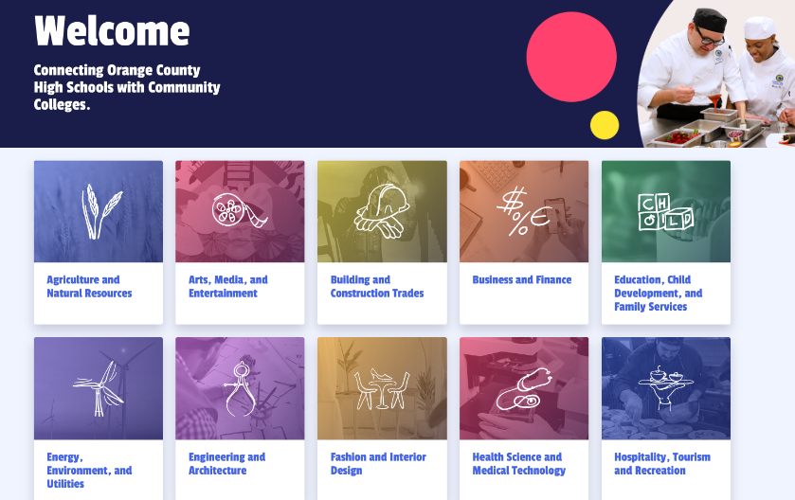
With the support of the CCCCO, the Orange County Program Finder is a tool being developed by an outside technology vendor called Concentric Sky. After a lengthy period (2 years) of requirements development and an investment of about $600-700k, a soft launch of one sector (Hospitality) has been tested with students with positive feedback.

The project started with more robust goals but the challenge of maintaining and giving access to student-level data proved difficult and so the tool has been scaled back for the “1.0” version. The primary audiences for the tool are K12 educators and counselors working with students and those at the colleges tasked with K12 engagement and program development. The first iteration of the tool includes:

- A landing page with the 15 sectors/industries available for selection
- The sector page allows the user to toggle between a view of Colleges or High Schools
- Pathways appear on the left and a map appears on the right
- The Colleges view shows the pathways available on the left, aligned to the TOP codes of CE courses offered by one or more of Orange County’s 9 community colleges
  - A map on the right side of the screen shows where the colleges are that offer pathways in that sector
  - A user may also select a specific pathway and the map will update to show where the colleges are that offer the selected pathway
  - A user may click on a college name on the map to go to a link determined by the college as the best destination for the user (e.g., the Culinary Arts program page on the college’s website)
- The High Schools view shows the pathways available on the left, aligned to the TOP codes of CE courses offered by one or more of Orange County high schools
  - A map on the right side of the screen shows where the K12 districts are that offer CE courses in that sector (plus number of high schools)
  - A user may also select a specific pathway and the map will update to show where the districts are that offer the selected pathway
  - A user may click on a district name on the map to go to a district information page
  - The district information page includes
    - Contact information for the district and ROP
    - A list of all CE pathways in the district and the high schools that offer them
    - The number of students in the pathway at that high school (which is the previous year’s de-identified enrollment data provided by CDE)

Orange County and Concentric Sky are open to other regions using the same technology to showcase their own local data. There would be a small annual maintenance/licensing cost (TBD but somewhere around $10k) and the cost of any region-specific data requirements or enhancements. To use the existing product as is, the region would need to:

- Populate their pathways in an Excel template
- Do an inventory of the TOP4 programs at the colleges
- Populate the contact information
- Provide a working URL for every TOP4 program for every college.

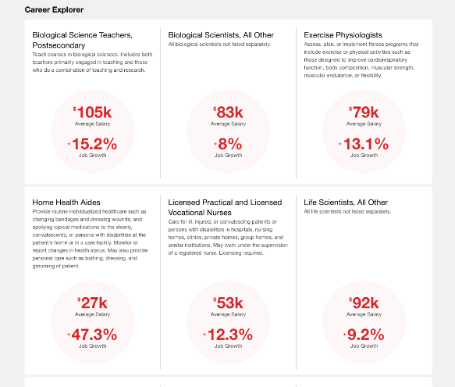
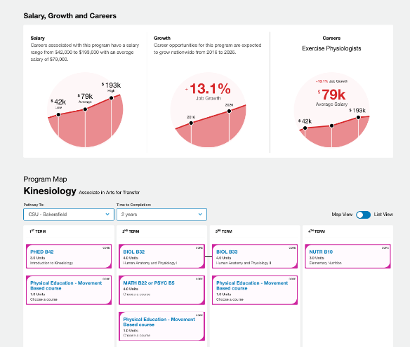
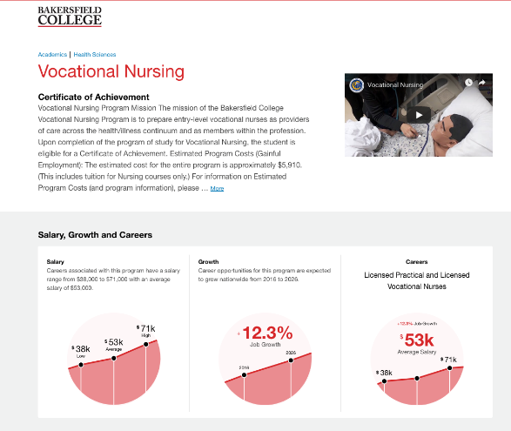
The Bakersfield College Program Pathways Mapper, also developed with support of the CCCCO and by Concentric Sky, provides information on careers associated with their college’s programs, including videos, typical wages, and the labor market demand in California. Each Pathway allows the user to explore a set of program maps that show a semester-by-semester path from program entry to completion.

Each pathway page combines career exploration information with the specific course maps offered by the college. Degrees, high unit certificates, and low unit certificates are listed for selection.

Selecting an education path leads to a page for that program’s information, including a video, program learning outcomes, salary, and demand.

Below this is the Program Map, where each semester’s courses are laid out in toggled (map or list) view. Certificate programs show the pathway to completion and career. Associate degree pathways show the pathway to transfer to a UC or CSU.

All courses are listed with their units and whether Core or General Ed. Each course may be selected to view its description. When there are several courses that will fulfill a requirement in the course map, the user is given a list and may choose a course to view its description.

This tool was the most favorably viewed by K12 stakeholders as supporting their students’ education planning needs.

Recommendation 4: Link to career exploration tools research
A number of the user needs identified by stakeholders address a larger scope of tools to support students as they navigate pathways from high school to college and into careers. Many of the use cases and requirements, such as students needing to explore careers, could be accommodated through a variety of existing career exploration and career services platforms. Tools in this category are being researched though Workgroups 1a and 3. Therefore, addressing the additional scope identified by stakeholders will require connecting to the career exploration tools research being conducted and determining if additional tools need to be developed/acquired. Currently, none of the career exploration tools being researched showcase pathway mapping from K12 to college programs.

Recommended Next Steps

- Establish decision-making/stakeholder group to guide and inform activities moving forward.
- Review the Tool Evaluation Rubric to finalize requirements, prioritize use cases and inform a phased plan for development and implementation.
- Document the phased development and implementation plan.
- Review existing tools with the prioritized Tool Evaluation Rubric.
  - Both Concentric Sky tools
  - Career exploration tools that address the high-priority use cases
- Document where no product meets specific requirements.
- Set up meetings with vendors/owners of tools that address priorities and for each
  - Document where the tool meets needs and where additional enhancements are required.
  - Research costs and time required to develop additional enhancements.
- Enter into required agreements with vendor(s), if cost /timing of enhancements is acceptable.
  - If cost/timing of enhancements exceeds benefit of leveraging existing tool(s), develop full technical specifications to inform a bid process for technology developers (i.e., cast a wider net)
- Develop a project plan and establish a project management team to work with the vendor(s) to implement solution.

