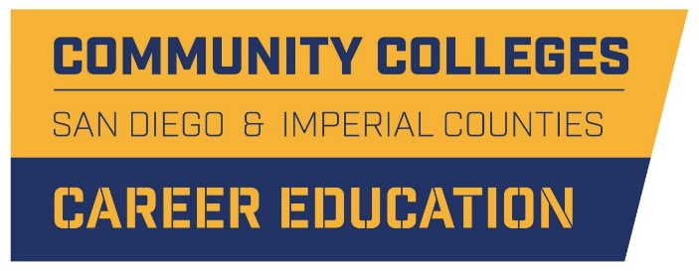

MIDDLE SCHOOL AND HIGH SCHOOL ENGAGEMENT
2019-2010 Goals

- Support regional awareness of CE

- Support career-related curriculum and career guidance at regional middle schools and high schools

- Create and expand regional WBL opportunities that add value to district efforts and expose students to regional industry sectors

- Create effective opportunities for postsecondary engagement for students as a means to support informed college entry

