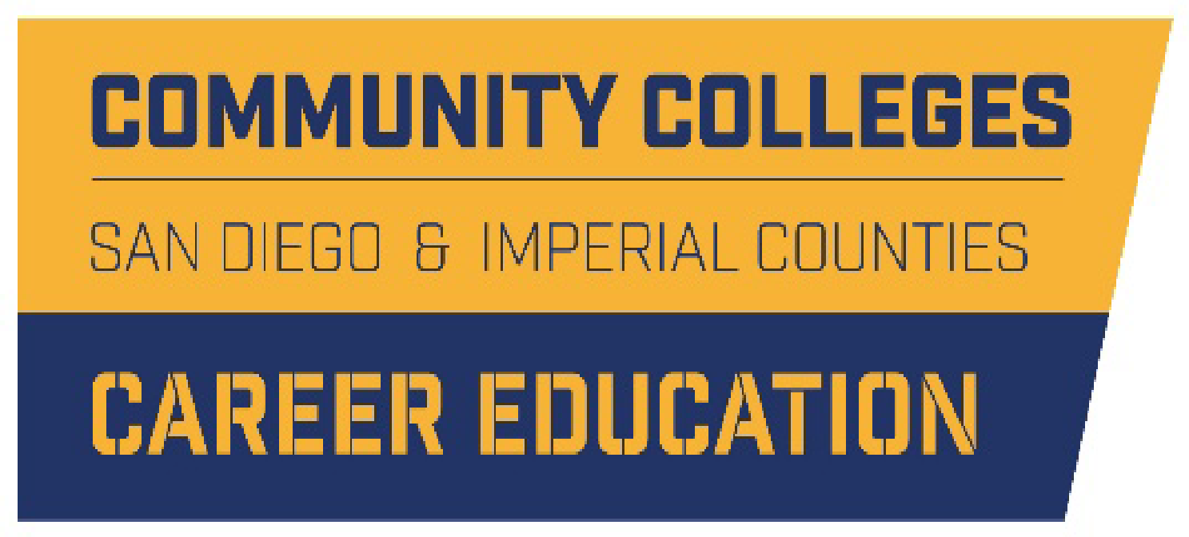
Career Pathways Meeting

A G E N D A

September 16, 2020
10:00-11:30 am

- Welcome and Introduction of New Leads (10 mins) K. Zant

- Purpose of Workgroup and Update (10 mins) K. Zant

- Fiscal Year 2020-21 Goals and Building a Community of Practice (10 mins)
- Goals & Long-Term Outcomes D. Cabanilla
- K14 Career Education Pathways Partnership Community of Practice A. Perman
  - Focus, Format, & Timing

- 2020-21 Priority Projects (25 mins)
  - Program Finder - Formal Launch, Marketing, and Sustainability A. Love
  - Early College Credit - Map of the Landscape D. Cabanilla
  - Data Project - Map of the Landscape D. Cabanilla

III. Community of Practice Roundtable Discussion (30 mins) A. Perman
Opportunity to share regionally relevant updates on current work, activities, events, and or/practices to support collective learning region wide
  - Regional Directors Updates
  - COE on Labor Market Demand Updates
  - Marketing Workgroup
  - MS/HS Engagement Workgroup
  - Adult Education and Noncredit Workgroup
  - K14 TAP and K12 Pathways Coordinators
  - Community College Outreach Roles
  - CTE Directors
  - County Office of Education
  - Other

- Closing ( 5 mins) Leads
  - Career Pathways Workgroup (Project Focused)- October & November
  - K14 Pathways Partnership Community of Practice - December

