DATE: | June 3, 2021
TO: | Career Education Deans and Chief Instructional Officers  San Diego and Imperial Counties Community Colleges
CC: | CEOs, CSSOs
FROM: | San Diego-Imperial Regional Consortium

Regional Strong Workforce Program (SWP) Request for Applications (RFA):
Strategies for Priority Occupations, Sectors and Economies

Please review this RFA carefully before completing the Letter of Intent and RFA Response Form below. The RFA Response Form will be used to develop the scope of work for the contract with your college after a consultation meeting with the Regional Consortium. (More information about this meeting is provided in the RFA Process and Timeline below.) The information submitted in the RFA Response Form will also be used to populate the SWP workplan in the statewide system NOVA.

If you have questions about the scope of this RFA, please contact Danene Brown at Danene.Brown@gcccd.edu or Sally Cox at Sally.Cox@gcccd.edu.

Please submit the completed Letter of Intent to Sue Fisher at Sue.Fisher@gcccd.edu.

Table of Contents
Section I: Introduction and RFA Purpose 3
Section II: Strategies for Priority Occupations, Sectors and Economies for Curriculum Alignment 4
Section III: RFA Process and Timeline 6
Section IV: Letter of Intent 8
Section V: Project/Intervention Consultation Meeting 11
Section VI: POSE RFA Application 13
Addendum A: Problem Statements and Possible Interventions (POSE Strategies) 18
Addendum B: Assessment/Analysis of Enrollment, Retention, Completion, Employment and Earnings of Students in Programs (Template) 18

Section I: Introduction and RFA Purpose
This RFA specifically addresses labor market needs in our region’s Priority Occupations, Sectors and Economies (POSE). The purpose of this RFA is to fund projects or interventions that 1) respond to regional employers’ workforce needs, 2) are supported by data and research, 3) aim to improve specific SWP outcomes or metrics, and 4) have a sustainability plan that examines the efficacy of the intervention and viability of implementing future improvements.
The Regional Consortium advises the San Diego and Imperial Counties Community Colleges to take into consideration the following continuous improvement model when applying for regional SWP funds and implementing their projects or interventions.

San Diego-Imperial Regional Consortium Continuous Improvement Model
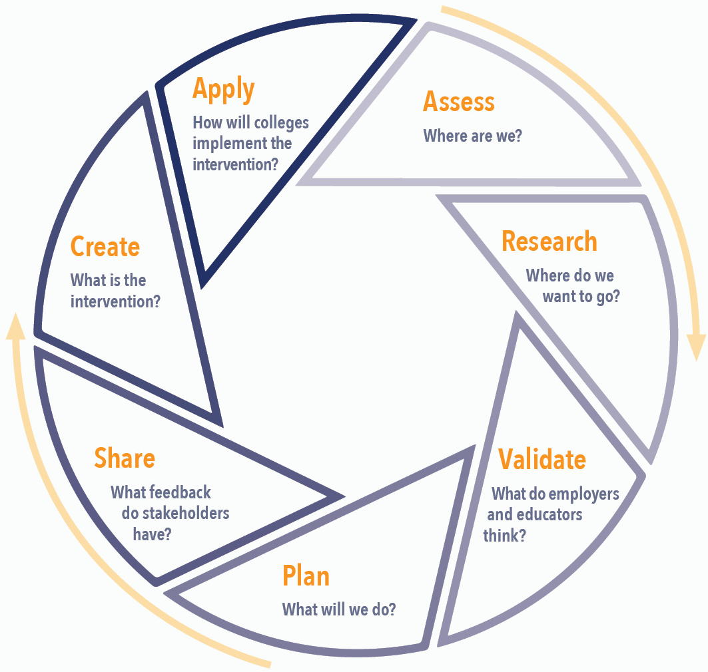

Section II: Strategies for Priority Occupations, Sectors and Economies for Curriculum Alignment
Attachment A of this RFA details the strategies for Priority Occupations, Sectors and Economies (POSE) that the San Diego and Imperial Counties Community Colleges could implement to address regional labor market needs. These strategies (i.e., problem statements and possible interventions) were crafted by the San Diego-Imperial Center of Excellence for Labor Market Research (COE) and the POSE’s respective Regional Directors for Employer Engagement. Projects outside the scope of the Sector Strategies in Attachment A must represent high-wage, high-demand CTE occupations and be supported by Labor Market information. In Section IV: Letter of Intent of this RFA, colleges are to select at least one of the POSE’s in Attachment A to provide an intervention or project for.
Six POSE strategies were offered in 2020—some strategies continue to evolve and may include additional phases. This RFA will be amended with revisions to Attachment A as POSE strategies become available.

Curriculum Alignment Requirement
The first step in implementing POSE strategies is to complete the curriculum alignment process. The primary goals of curriculum alignment are to:
- Align curriculum with the knowledge, skills, and abilities (KSAs) that employers need for targeted occupation(s)
- Improve retention, success and completion of students in identified career pathway(s)
- Scale institutional practices that improve equity for all students in the programs of study
All colleges must demonstrate that their curriculum is in alignment with the POSE’s KSAs before implementing a project or intervention. KSAs are provided for each POSE in Attachment A. If the curriculum is not aligned, then the college must conduct a curriculum alignment project. The following steps outline the curriculum alignment process:
- Create an inventory of all courses in the designated program. The inventory should delineate certificate and degree programs, courses, articulation agreements, and careers.
- Realign programs to industry needs.
  - Identify redundancies to streamline curriculum.
  - Update curriculum to align with industry KSAs presented in this RFA.
  - Intentionally embed the 21st Century Employability Skills specified as important by employers.
  - Clarify stackability or design stackable credentials for the career pathway(s).
  - Create a career pathway diagram to include courses, certificates, degree, occupations and certifications.
- Mitigate disproportionate impact across diverse student populations.
  - Conduct an assessment/analysis of the enrollment, retention, completion, employment, and earnings of these courses/programs (see Attachment B for template).
  - Use disaggregated data to analyze disproportionate impact in the classes based on college service area demographics and student performance. Analyze enrollment, course retention and success, program completion, employment and wage gain.
  - Embed strategies into the instructional delivery model of the designated courses to improve retention, success and completion.
- Integrate work-based learning.
  - In collaboration with Work-based Learning Coordinators, integrate a continuum of work-based learning into the instructional delivery model of all courses in the program(s).
- Implement strategies for improving course retention and success in classes with below-average retention and success rates.

Section III: RFA Process and Timeline
This section outlines the RFA process, including key milestones and timeline. While the timeline below is optimal, there are opportunities to apply for funding after these timelines as funds are available.
Milestone 1: Complete Section IV: Letter of Intent and submit it to the Regional Consortium
Complete Section IV: Letter of Intent and submit it to the Regional Consortium. The letter of intent will represent your institution’s intent to respond to this RFA. The letter of intent requires that colleges submit a problem statement and the project description. Attachment A: Problem Statements and Possible Interventions has been included in this RFA to assist the colleges with completing the letter of intent. A separate letter of intent must be submitted for each proposed intervention or project.
Milestone 2: Attend project/intervention consultation meeting(s) with the Regional Consortium and discuss Section IV and V
The Regional Consortium will schedule a project/intervention consultation meeting with your college after receiving Section IV: Letter of Intent. At the initial project/intervention consultation meeting, the Regional Consortium will discuss with the college the specifics of Section V: RFA Response Form. It is recommended that the colleges have a draft RFA Response Form ready for the initial consultation meeting, so that the Regional Consortium could determine if revisions to your draft RFA Response Form(s) are necessary before finalizing the scope of work. The initial consultation meeting will determine the extent of the revisions and if another meeting is necessary. The Regional Consortium will also discuss what deliverables must be submitted and how funding will be distributed (i.e., funding model). Please be aware that this will be an iterative process as it is customized to each college’s intervention or project. Consultation meetings with the Regional Consortium are intended to be collaborative.
The purpose of the consultation meetings is to confirm that the intervention supports the goal of this RFA, which is to fund projects or interventions that 1) respond to regional employers’ workforce needs, 2) are supported by data and research, 3) aim to improve specific SWP outcomes or metrics, and 4) have a sustainability plan that examines the efficacy of the intervention and viability of implementing future improvements. Before the scope of work can be finalized, all institutions interested in responding to this RFA must have at least one project/intervention consultation meeting with the Regional Consortium.

Milestone 3: Submit final draft of RFA Response Form to the Regional Consortium
After completing the consultation meeting(s) with the Regional Consortium, a final draft of Section V: RFA Response Form will be completed. The Regional Consortium and the college should have met and finalized the following:
- Scope of work of the contract based on the RFA Response Form
- Total funding amount for the project(s) or intervention(s)
- Deliverables that the college must submit to receive payments
- Payment schedule and distribution amounts based on the deliverables’ due dates
- Quarterly progress report contents (e.g., what information should be included in NOVA’s quarterly report to demonstrate the intervention’s progress)

Milestone 4: Execute contract with Regional Consortium and submit quarterly reports
After the Regional Consortium receives the final draft of the RFA Response Form, an award letter will be sent to your institution, followed by a contract, which includes the scope of work, deliverables, etc. as discussed in the project/intervention consultation meeting(s). The period of performance of the contract will begin on July 1, 2021 or whenever the contract is finalized.
Once your institution and the Regional Consortium execute the contract, the Regional Consortium will make payments based on the agreed upon payment schedule from the consultation meeting(s).
The Regional Consortium expects timely reports to be submitted in NOVA, containing the information as discussed in the consultation meeting(s).

Timeline
Milestone | Date(s)
Complete Section IV: Letter of Intent and submit it to the Regional Consortium | June 15, 2021
Attend project/intervention consultation meeting(s) with the Regional Consortium and discuss Section IV: Letter of Intent and Section V: RFA Response Form | Rolling
Last day to submit final draft of Section V: RFA Response Form to the Regional Consortium | September 30, 2021
Execute contract with Regional Consortium | July 1, 2021- Rolling
Attend POSE Community of Practice | Quarterly
Submit progress reports for the duration of the project | Quarterly

Section IV: Letter of Intent
Instructions: Fill in the fields below with the appropriate information. This form represents your college’s intent to respond to this RFA. Please complete a separate letter of intent for each Priority Occupation, Sector and Economy intervention you plan to implement, if you choose to address more than one problem statement.

Institution Name
Project Lead (First & Last Names)
Project Lead Email

- Development: Is this a new program or update to an existing program?
  - New program
  - Update to existing program

- Acceleration: Will this project offer an accelerated or short-term option? (“Short-term workforce training program” means a 4 to 12-week program designed for targeted reskilling and upskilling that results in job placement)
  - Yes
  - No

- Problem Statement: Which regional labor market need does your college propose to address? Select only one.
PLEASE NOTE: Additional projects may be added to the RFA pending research and presentation to the Workforce Development Council.

- New Priority Occupation, Sector and Economy Project (Must be CTE- high-demand, high- wage, middle-skill)
- PHASE Two for Existing Project

- Curriculum Alignment: As mentioned in Section II, colleges must demonstrate that their curriculum is in alignment with the Priority Occupations, Sectors and Economies’ KSAs before implementing a project or intervention for the POSE. The steps for curriculum alignment have been provided in Section II. However, if your college prefers to not complete a curriculum alignment project, then describe how your curriculum is currently aligned with the KSAs identified in Attachment A. If your college does plan to conduct a curriculum alignment project, then enter “N/A” for this question.

- Administrators and Faculty Participating in the Project: Please provide a list of the Administrators and Faculty (Full-time and Adjunct) working on this project.

Name | Email

- Program Codes: Please list the SOC codes and TOPS codes covered or included in this project.

- Employment: What type of employment/jobs does this program prepare students for?

- Description of Proposed Project: What intervention or project does your college propose to implement? How will you address the needs as described in the problem statement? What will change at your college? What will be developed? How will your project improve the SWP metrics (Refer to Attachment A for possible interventions, if needed)?

Section V: Project/Intervention Consultation Meeting
Instructions: This portion will be completed together by the college and the Regional Consortium during the consultation. This section will be used to inform the SWP workplan in NOVA and the contract scope of work with the Regional Consortium.

- Welcome and Introductions
- Program Improvement Proposal

  - Problem Statement: Describe the problem you are trying to solve.
    - Notes:

  - Curriculum: Will the college conduct the curriculum assessment or alignment process before beginning their project? Why or why not?
    - Notes:

  - Metrics: Which SWP metric(s) do you expect to impact with your proposed project or intervention? Please note: The RFA Application will require colleges to provide SWP metric(s) baseline and baseline year data.
    - Notes:

  - Investment Plan: How will you use the funding? How will you leverage additional resources to accomplish your project goals? (For example, “The College will use local SWP funds to market our programs to increase enrollments and use regional SWP funds to increase capacity by…”)
    - Notes:

POSE/Program

Required | College Contribution | Regional Contribution | Funding Year 2021 or 2022+
Curriculum
Modality (Online or In-Person)
Faculty
Facility
Equipment
Supplies/Consumables
Marketing
Scheduling (Short-term/Accelerated)
Staff Support (Temp/One Year)
Other

  - Target Population: How will this project increase representation of underrepresented groups in this POSE?

  - Major Outcomes or Leading Indicators: What indicators or outcomes (e.g., college action plans completed) will you track to assess the efficacy of your intervention? What are the goals and intended outcomes of your intervention?

  - Implementation and Sustainability: How will you ensure ongoing implementation beyond the period of performance of this funding?

  - Budget: Colleges must submit a detailed budget describing how the proposed intervention will move the selected SWP metrics. The budget should reflect the topics discussed above. How much funding is requested? How will the funding be used during the period of performance?

Section VI: POSE RFA Application
Instructions: Fill in the fields below with the appropriate information; however, this form will not be finalized until after the consultation meeting(s) with the Regional Consortium. This form will be used for the SWP workplan in NOVA and the contract scope of work with the Regional Consortium.
- Administrators and Faculty Participating in the Project: Please provide a list of the Administrators and Faculty (Full-time and Adjunct) working on this project.

Name | Email

- Target Population: Which population(s) will you target with this project? How will they benefit? For example, are certain demographics (e.g., age, gender, ethnicity) disproportionately enrolling, completing, and/or succeeding in your programs? How will this project increase representation of underrepresented groups in this sector?

- Program Codes: Please list the SOC codes and TOPS codes covered or included in this project.

- Major Outcomes or Leading Indicators: What indicators or outcomes (e.g., college action plans completed) will you track to assess the efficacy of your intervention? What are the goals and intended outcomes of your intervention?

- Metrics: Which SWP metric(s) do you expect to impact with your proposed project or intervention? Provide the baseline and baseline year. For metrics that do not apply, put “N/A.”
Metric | Baseline | Baseline Year
Number of Enrollments
Course Retention
Course Success
Students Who Earned 9+ Units in a Year
Number of Students Who Achieved a Noncredit Milestone
Number of Students Who Got a Degree, Certificate, or Apprenticeship Journey Status
Number of Students Who Transferred
Job Placement
Percentage Who Attained a Living Wage

- Implementation and Sustainability: How will you ensure ongoing implementation beyond the period of performance of this funding? How will you examine the ongoing effectiveness of your intervention or project?

- Investment Plan: How will you use the funding? How you will leverage additional resources to accomplish your project goals? (For example, “The College will use local SWP funds to market our programs to increase enrollments and use regional SWP funds to increase capacity by…”) Refer to the itemized list of budgeted expenses on the following page, when necessary, to describe your investment plan.

- Budget: Colleges must submit a detailed budget describing how the proposed intervention will move the metrics. Provide a detailed budget for each year below. This funding is only available through June 30, 2022 (exact dates will be released by the fiscal agent).

Year 1 Budget: July 1, 2021 - June 30, 2022
Object | Classification | Itemized List of Budgeted Expenses | Total
1000 | Instructional Salaries
2000 | Non-instructional Salaries
3000 | Employee Benefits
4000 | Supplies and materials
5000 | Other Operating Expenses and Services
6000 | Capital Investment*
Total Program Costs**

*Colleges should not use regional SWP funds for 6000 unless there is a sustainability plan (e.g., sustained with local funds). Using funding for Capital Investment would only be appropriate to establish a classroom space for a new program or to increase capacity of an existing program.
**Indirect is not permitted on this project.

- Signature Page

Career Education Dean
Signature |  | Date
First and Last Names (Printed) |  | Title
Chief Instructional Officer
Signature |  | Date
First and Last Names (Printed) |  | Title
College President
Signature |  | Date
First and Last Names (Printed) |  | Title

Addendum A: Problem Statements and Possible Interventions (POSE Strategies)
The data linked in this section provides an overview of the labor market challenges in our region’s Priority Occupations, Sectors and Economies—specifically those addressable by the San Diego and Imperial Counties Community Colleges. These problem statements and their possible interventions were crafted by the San Diego-Imperial Center of Excellence for Labor Market Research (COE) and the POSE’s respective Regional Directors for Employer Engagement (Regional Directors).
Your college may choose to address any one of the following POSE’s problem statements (or statements of need) to respond to in Section IV: Letter of Intent. If you choose to address more than one POSE with your intervention or project, then submit a separate letter of intent for each.
Please note that this RFA will be amended to include more Priority Occupations, Sectors and Economies as the information becomes available.
Problem Statements, Interventions, and Presentations

Addendum B: Assessment/Analysis of Enrollment, Retention, Completion, Employment and Earnings of Students in Programs (Template)
Instructions:
- For each metric (enrollment, retention, completion, employment, and earnings), use the following template and your college’s definition of these metrics to provide an assessment/analysis of your courses and department.
- This template provides an example of how to analyze enrollment rates. Replace the gray-shaded font with the appropriate metric name when replicating this template for other metrics (retention, completion, completion, employment, and earnings).

Enrollment Rates by Demographic

- What are the enrollment rates for the community college overall, department, and course for each demographic below (i.e., race/ethnicity, gender, age group)?

Race/Ethnicity | Community College Overall % |  | % of Students in Course |  | Department %
African American | % |  | % |  | %
American Indian/Alaska Native | % |  | % |  | %
Asian | % |  | % |  | %
Filipino/a | % |  | % |  | %
Hispanic | % |  | % |  | %
Pacific Islander | % |  | % |  | %
Two or More Races | % |  | % |  | %
White | % |  | % |  | %
Other, unreported or N/A | % |  | % |  | %

Gender | Community College Overall % |  | % of Students in Course |  | Department %
Male | % |  | % |  | %
Female | % |  | % |  | %
Other, unreported, or N/A | % |  | % |  | %

Age Group | Community College Overall % |  | % of Students in Course |  | Department %
19 or younger | % |  | % |  | %
20-24 | % |  | % |  | %
25-29 | % |  | % |  | %
30-34 | % |  | % |  | %
35-39 | % |  | % |  | %
40 and older | % |  | % |  | %
Other, unreported or N/A | % |  | % |  | %

- Based on the student demographic data for enrollment, retention, completion, completion, employment and earnings, answer the following open-ended questions.

  - What trends do you see among the different demographics? Do certain demographics have higher rates in your courses or department than the college overall, depending on the metric? Why do you think these trends exist?

- Do you have any demographics with a high retention rate, but low success rate? Conversely, do you have any demographics with a low retention rate, but high success rate? If so, why do you think these trends exist?

  - Are you interested in increasing the enrollment, retention, success, etc. rates of a specific demographic? If so, what would be your next steps?

